 | Time | Class | Instructor | Location
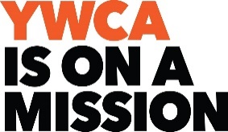  Monday | 8:00 AM 45 min.  9:00 AM 1 hr  9:15 AM 45 min.  10:15 AM 45 min  10:15 AM 1 hr. | Sit & Move  Keep Movin  March Into Fit  Sr. Strength Training  Yoga (no class Dec 29) | Jimmi  Jimmi  Emma  Emma  Alexes | Studio A  Studio A  Studio B  Studio A  Studio B
Tuesday | 8:00 AM 45 min  9:00 AM 45 min  10:00 AM 45 min  11:00 AM 45 min | Get Your Sit On!  Strong Stretch Balance  Pom Poms  Sr. Yoga | Brigitte  Emma  Emma  Lynn | Studio A  Studio A  Studio A  Studio A
Wednesday | 8:00 AM 45 min  9:00 AM 45 min  9:15 AM 45 min  10:00 AM 90 min  10:30 AM 1 hr. | Cardio Time  Sr. Strength Training  HIIT  Chair Volleyball  Yoga (no class Dec 24, 31) | Teresa  Emma  Teresa  Emma  Alexes | Studio A  Studio A  Studio B  Studio A  Studio B
Thursday | 8:00 AM 45 min  9:00 AM 45 min  10:00 AM 45 min  10:00 AM 45 min | Get Your Sit On!  Floor to Standing Transitioning  Weight Training 101  Sr. Yoga | Brigitte  Emma  Liz  Lynn | Studio A  Studio B  Fitness Center  Studio A
Friday | 8:00 AM 45 min  9:00 AM 1 hr.  10:15 AM 1 hr. | Sit & Move  Keep Movin’  Yoga (Dec 12, 19) | Jimmi  Jimmi  Ryan | Studio A  Studio A  Studio B
Saturday | 9:15 AM 90 min.  10:00 AM 45 min | Chair Volleyball (Dec 6)  HIIT (Dec 20) | Emma  Emma | Studio A  Studio A
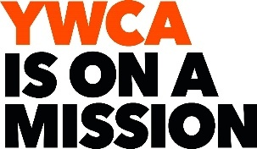
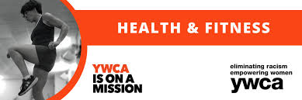

YWCA DEC 2025 Group Ex Class Schedule
Hours of Operation: M-F 7:00am-3:00pm, Sat 7:00am-2:00pm, Sun closed
1300 S. Main St. Winston Salem, NC 27127 336-354-1589 www.ywcaws.org
DEC 24, 31: CLOSING AT 2PM CHRISTMAS DAY: CLOSED

