 | Time | Class | Instructor | Location
  Monday | 8:00 AM 45 min  9:00 AM 1 hr  9:15 AM 45 min  10:15 AM 45 min  10:30 AM 1 hr  11:15 AM 90 min | Sit & Move  Keep Movin  March Into Fit 15th, 22nd, 29th  Sr. Strength Training 15th, 22nd, 29th  Yoga  Chair Volleyball 15th, 22nd, 29th | Jimmi  Jimmi  Emma  Emma  Alexes  Emma | Studio A  Studio A  Studio B  Studio A  Studio B  Studio A
Tuesday | 8:00 AM 45 min  9:00 AM 45 min  10:00 AM 45 min  11:00 AM 45 min | Get Your Sit On!  Strong Stretch Balance 16th, 23rd, 30th Pom Poms 16th, 23rd, 30th  Sr. Yoga | Brigitte  Emma  Emma  Lynn | Studio A  Studio A  Studio A  Studio A
Wednesday | 8:00 AM 45 min  9:00 AM 45 min  10:00 AM 90 min  10:30 AM 1 hr | Cardio Time  Sr. Strength Training  Chair Volleyball  Yoga | Teresa  Emma  Emma  Alexes | Studio A  Studio A  Studio A  Studio B
Thursday | 8:00 AM 45 min  9:00 AM 45 min  10:00 AM 45 min  10:00 AM 45 min  11 AM 1 hr | Get Your Sit On!  Floor to Standing Transitioning  Weight Training 101  Sr. Yoga  Yoga for Mobility & Joint Health | Brigitte  Emma  Liz  Lynn  Alexes | Studio A  Studio A  Fitness Center  Studio A  Studio B
Friday | 8:00 AM 45 min  9:00 AM 1 hr  10:15 AM 1 hr | Sit & Move  Keep Movin’  Yoga | Jimmi  Jimmi  Ryan | Studio A  Studio A  Studio B
Saturday | 10:00 AM 90 min  10:00 AM 45 min | POP-UP Chair Volleyball 6th  HIIT Class 13th, 20th, 27th | Emma  Emma | Studio A  Studio A
YWCA June 2026 Group Ex Class Schedule

Hours of Operation: M-F 7:00am-3:00pm, Sat 7:00am-2:00pm, Sun closed
1300 S. Main St. Winston Salem, NC 27127

336-354-1589 www.ywcaws.org
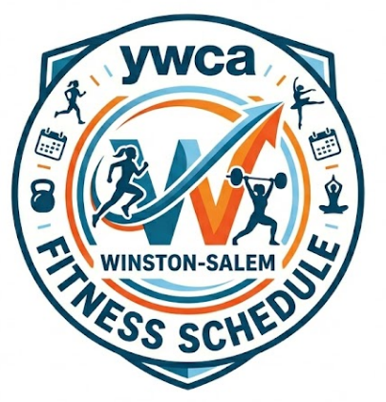
Questions? Email info@ywcaws.org


